- Financial Consideration

Description | Price (Rs.)
Design of the solution
- 4U Rack X 1
- 24 Port Patch Panel X 2 ( 1Y Warranty)
- 24 switches X 2 ( 1Y Warranty)
- Data Points X 32
- Voice Points X 27

Total Project Cost | 160,200.00

- Conduit Layout plane

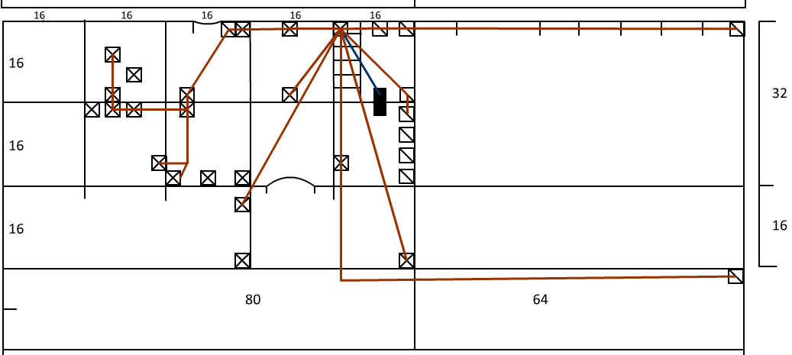

- Terms & Conditions

- All Data Points will be tested by team before handed over to the customer, voice point testing will be completed after customer has provided with PBX system.

- This proposed solution only covers physical connectivity among client nodes; hence any security threat from viruses, hackers or adult content neither filtering nor restrictions to access network resource will not be covered. Client is advised with a security solution to minimize above threats.

- Our team should be given with access to the building/rooms when necessary during the installation period and if required thereafter.

